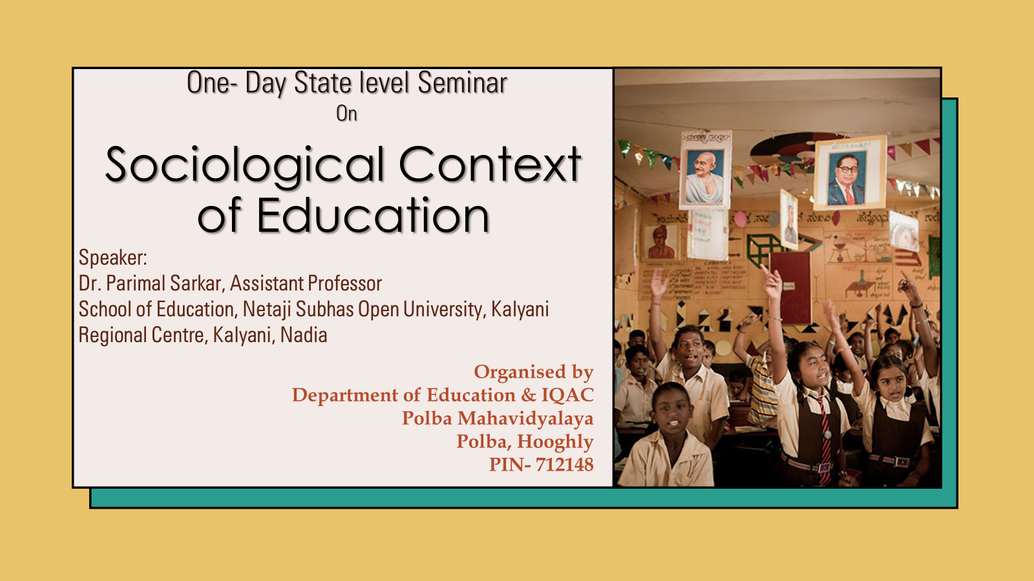

**REPORT ON ONE-DAY STATE-LEVEL SEMINAR**

**“SOCIOLOGICAL CONTEXT OF EDUCATION”**

**on**

**10th March 2023**

Department of Education in collaboration with the Internal Quality assurance Cell, Polba Mahavidyalaya had organized a one-day State Level Seminar on “Sociological Context of Education” on 10th March, 2023.

The seminar focused on the sociological perspective of Education. The programme started at 10:30 am with a welcome address by Mr. Bharat Maji. The dignitaries on the dias were Dr. Parimal Sarkar, Assistant Professor, School of Education, Netaji Subhas Open University, Mr. Narugopal Kaibarta, TIC, Dr. Kaliprasad Mishra, Associate Professor and HoD, Department of Sanskrit, Dr. Santanu Sengupta, IQAC Coordinator and Assistant Professor, Department of History. An inaugural speech was given by Mr. Narugopal Kaibarta and an introduction of the programme was given by Mr. Bharaj Maji. He highlighted that This sociological perspective focuses on social interaction in the classroom, on the playground, and in other school venues. Specific research finds that social interaction in schools affects the development of gender roles and that teachers' expectations of pupils' intellectual abilities affect how much pupils learn.

Dr. Sohini Ghosh enlightened us by discussing functional and Conflict theory that does not dispute most of the functions just described. However, it does give some of them a different slant and talks about various ways in which education perpetuates social inequality (Hill, Macrine, & Gabbard, 2010; Liston, 1990). One example involves the function of social placement. As most schools track their students starting in grade school, the students thought by their teachers to be bright are placed in the faster tracks (especially in reading and arithmetic), while the slower students are placed in the slower tracks; in high school, three common tracks are the college track, vocational track, and general track.

Such *tracking* does have its advantages; it helps ensure that bright students learn as much as their abilities allow them, and it helps ensure that slower students are not taught over their heads. But, conflict theorists say, tracking also helps perpetuate social inequality by *locking* students into faster and lower tracks. Worse yet, several studies show that students’ social class and race and ethnicity affect the track into which they are placed, even though their intellectual abilities and potential should be the only things that matter: white, middle-class students are more likely to be tracked “up,” while poorer students and students of color are more likely to be tracked “down.” Once they are tracked, students learn more if they are tracked up and less if they are tracked down. The latter tend to lose self-esteem and begin to think they have little academic ability and thus do worse in school because they were tracked down. In this way, tracking is thought to be good for those tracked up and bad for those tracked down. Conflict theorists thus say that tracking perpetuates social inequality based on social class and race and ethnicity (Ansalone, 2006; Oakes, 2005).

Social inequality is also perpetuated through the widespread use of standardized tests. Critics say these tests continue to be culturally biased, as they include questions whose answers are most likely to be known by white, middle-class students, whose backgrounds have afforded them various experiences that help them answer the questions. They also say that scores on standardized tests reflect students’ socioeconomic status and experiences in addition to their academic abilities. To the extent this critique is true, standardized tests perpetuate social inequality (Grodsky, Warren, & Felts, 2008).

As we will see, schools in the United States also differ mightily in their resources, learning conditions, and other aspects, all of which affect how much students can learn in them. Simply put, schools are unequal, and their very inequality helps perpetuate inequality in the larger society. Children going to the worst schools in urban areas face many more obstacles to their learning than those going to well-funded schools in suburban areas. Their lack of learning helps ensure they remain trapped in poverty and its related problems.

Conflict theorists also say that schooling teaches a hidden curriculum, by which they mean a set of values and beliefs that support the status quo, including the existing social hierarchy (Booher-Jennings, 2008). Although no one plots this behind closed doors, our schoolchildren learn patriotic values and respect for authority from the books they read and from various classroom activities

The rerource person discussed the Objectives of the Seminar, Mr. Bharat Maji, Assistant Professor, Department of Education said that, “This seminar is aimed at Functional theory that stresses the functions that education serves in fulfilling a society’s various needs. Perhaps the most important function of education is *socialization*. If children need to learn the norms, values, and skills they need to function in society, then education is a primary vehicle for such learning. Schools teach the three Rs, as we all know, but they also teach many of the society’s norms and values.

A other function of education is *social integration*. For a society to work, functionalists say, people must subscribe to a common set of beliefs and values. As we saw, the development of such common views was a goal of the system of free, compulsory education that developed in the 19th century.

A third function of education is *social placement*. Beginning in grade school, students are identified by teachers and other school officials either as bright and motivated or as less bright and even educationally challenged. Depending on how they are identified, children are taught at the level that is thought to suit them best. In this way they are prepared in the most appropriate way possible for their later station in life.

*Social and cultural innovation* is a fourth function of education. Our scientists cannot make important scientific discoveries and our artists and thinkers cannot come up with great works of art, poetry, and prose unless they have first been educated in the many subjects they need to know for their chosen path.

Education also involves several *latent* functions, functions that are by-products of going to school and receiving an education rather than a direct effect of the education itself. One of these is *child care*. Once a child starts kindergarten and then first grade, for several hours a day the child is taken care of for free. The *establishment of peer relationships* is another latent function of schooling. Most of us met many of our friends while we were in school at whatever grade level, and some of those friendships endure the rest of our lives. A final latent function of education is that it *keeps millions of high school students out of the full-time labor force*. This

After the completion of the technical session I, lunch was served.

In technical session II, Mr. Bharat Maji, Assistant Professor, Department of Education and Mr. Ashish Mondal, Department of Education delivered their valuable lectures on Inclusive education followed by a discussion with students fact keeps the unemployment rate lower than it would be if they were in the labor force.

.

The programme wrapped up around 5:00 pm. The vote of thanks which was given by Mr. Ashish Mondal.

Thank You

**Student Registration**

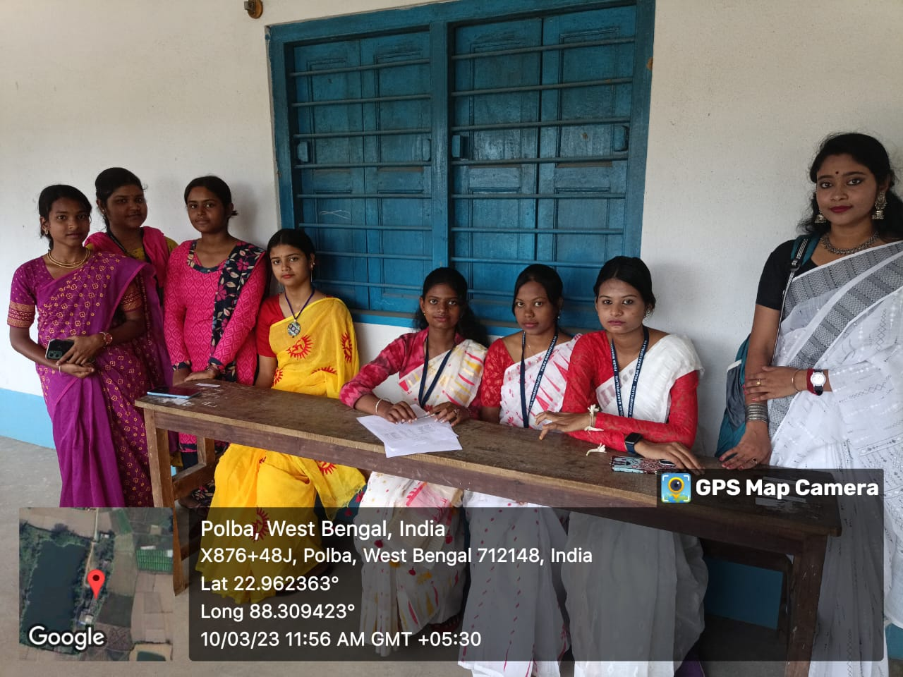

**State Level Seminar**

**“SOCIOLOGICAL CONTEXT OF EDUCATION”**

**dated**

**20th February 2024**

**Sloka on Mangalacharan**

**Objectives of the Seminar**

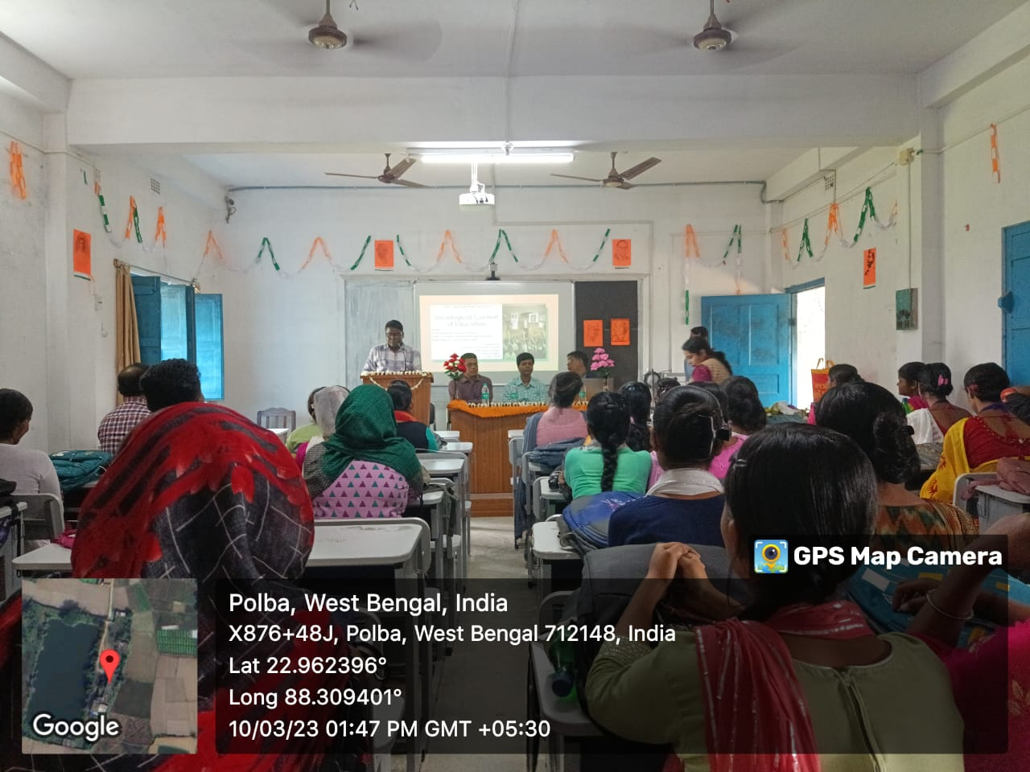

**Felicitation to the TIC**

**Felicitation to Dr. Kali Prasad Mishra**

**Felicitation to the Resource Person**

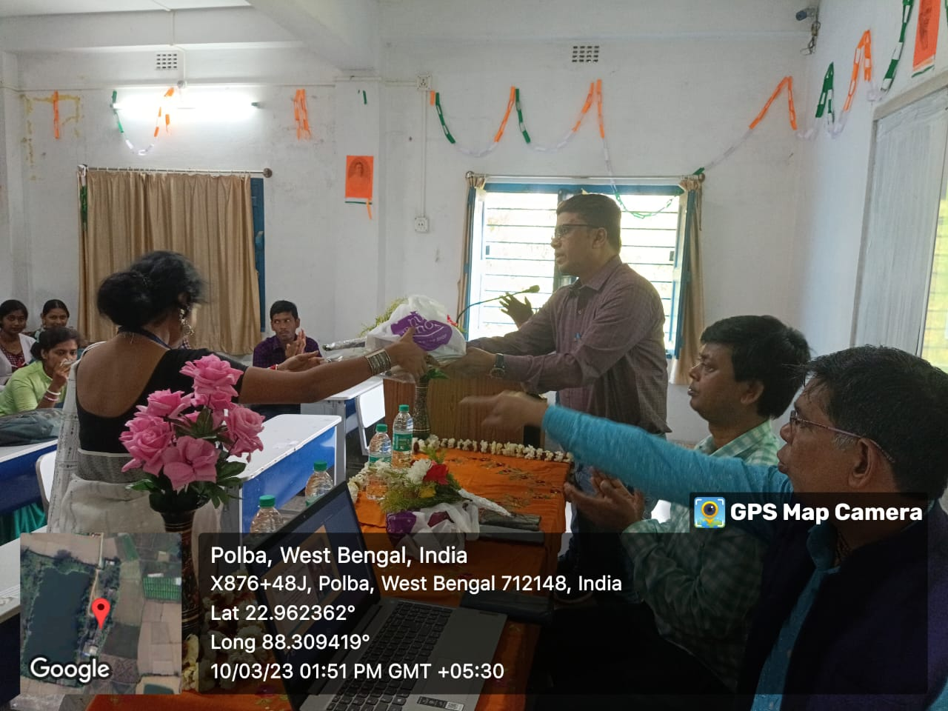

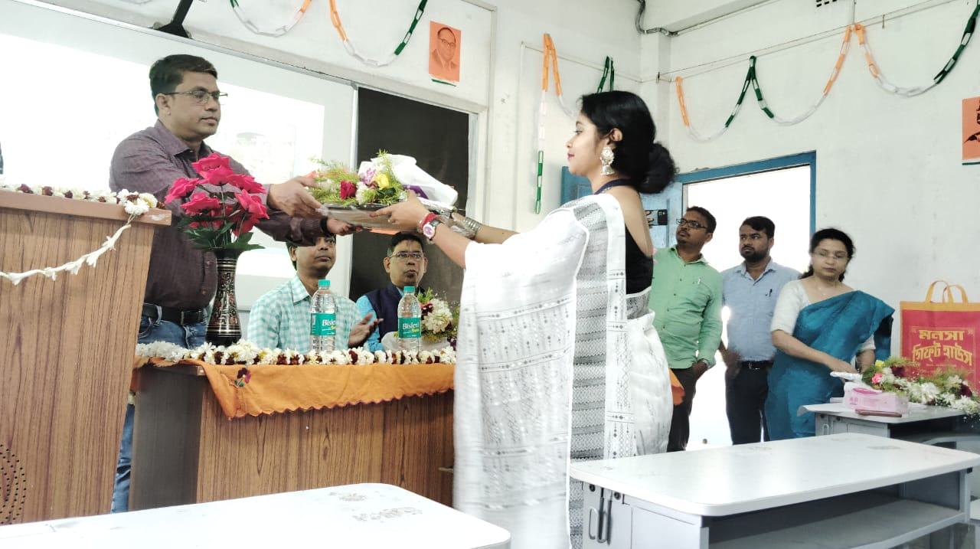

**Felicitation to the IQAC Coordinator**

**Felicitation to the Seminar Committee Convenor**

**Lamp Lighting**

**Inaugural Speech by TIC**

**Speech By Dr. Kali Prasad Mishra**

**Keynote Speech by**

Dr. Sohini Ghosh

Assistant Professor

Department of Education

**Technical Session I**

Speech I

Dr. Sohini Ghosh

Department of Education

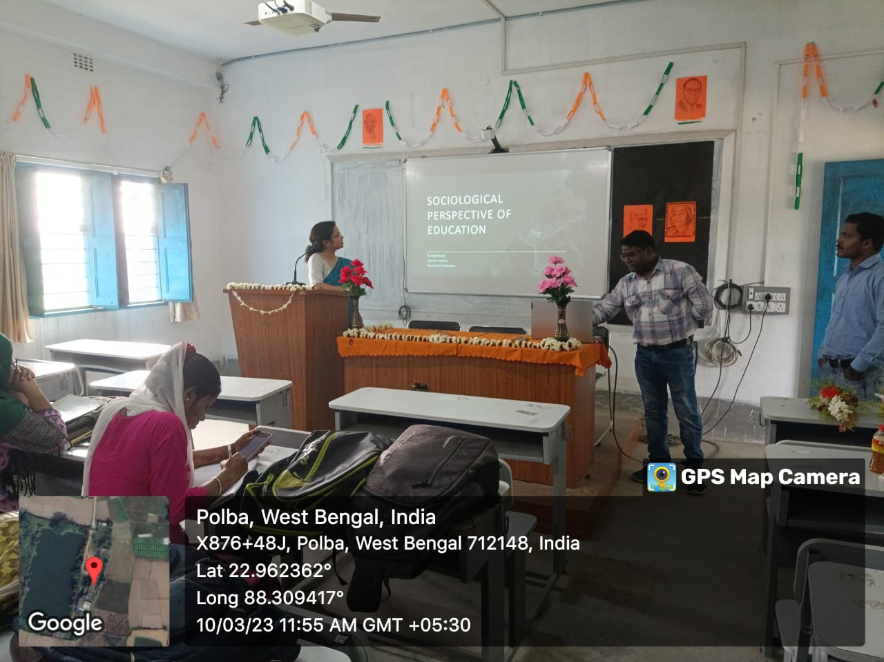

**Technical Session II**

Speech II

Dr. Parimal Sarkar

Assistant Professor, NSOU

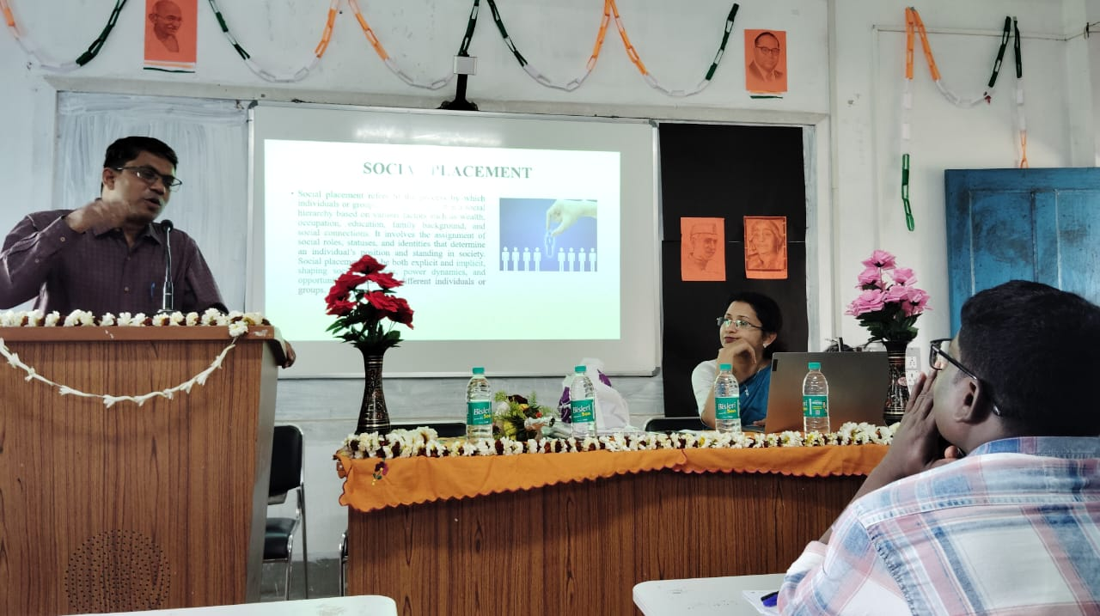

**Vote of Thanks**

Ashish Mondal

Department of Education

=

